


Version: 5.0.0
Published date: February 2026
Copyright © 2026 by ESW. All rights reserved. Information contained herein is subject to change without notice.

Spark Pricing
INTEGRATION GUIDE

SFCC - ESW Cartridge
+
Table of Contents
1. Spark Pricing Integration 3
  - 2. Order flow 3
  - 3.Enable Spark Pricing on retailer’s website 3
  - 3.1.Import metadata 3
  - 3.2.BM Configurations 4
  - 4.Code Customization 6
  - 4.1Example Screenshots – Adding class to elements in SFRA 7

Spark Pricing Integration

To ensure retailer’s customers always see accurate, up-to-date prices, the ESW SFCC cartridge offers a frontend solution as well which uses the store’s base currency prices and updates them directly on the storefront using JavaScript.

This means prices are refreshed in real time as customers browse, without needing server-side integrations. It’s a lightweight, browser-based approach that helps keep your storefront aligned with ESW pricing.

Order flow
When Spark pricing is turned on, the store sends product prices in the base currency (like USD or EUR). But shoppers won’t see those base prices. Instead, ESW automatically converts them into the shopper’s local currency based on their shipping country, right at checkout. This means the shopper always see prices in their own currency
.

Enable Spark Pricing on retailer’s website
Before enabling Spark pricing integration, please ensure that:
- The Spark feature is already configured correctly on the ESW tenant side. If needed, the ESW integration team can assist you with this setup.
- Spark pricing integration works only with dynamic pricing countries and will not function for fixed-price configurations.
- Developer effort is required to add specific HTML classes in the codebase to ensure pricing-related conversions are properly reflected in the HTML DOM.
- Threshold promotions (ESW Promotions Integration - Developer Resources - ESW Knowledge Centre) are not supported in Spark-enabled countries.
To enable Spark pricing on the storefront, retailers need to follow a few configuration steps as outlined below sections

Import metadata
Import Metadata:
Retailer needs to Import site preference attributes (systemobjects_spark.xml) from link_eshopworld\sitesdata\meta.
After importing meta data, retailer should be able to see following in the SFCC BM

BM Configurations
Spark Integration Configuration:
The preference group “ESW SPARK Integration Configuration” also includes attributes for the iframe checkout feature however, this section focuses only on the attributes related to the Spark pricing conversion feature.
The “ESW SPARK Integration Configuration” group can be found under Merchant Tools > Site Preferences > Custom Site Preference Groups > ESW SPARK Integration Configuration and includes the following attributes::
- ESW SPARK Script Path: This is the URL of the Spark JavaScript provided by the ESW.
ESW SPARK Dynamic Pricing Enabled: Set this to Yes to enable Spark pricing conversion, or No to disable it.
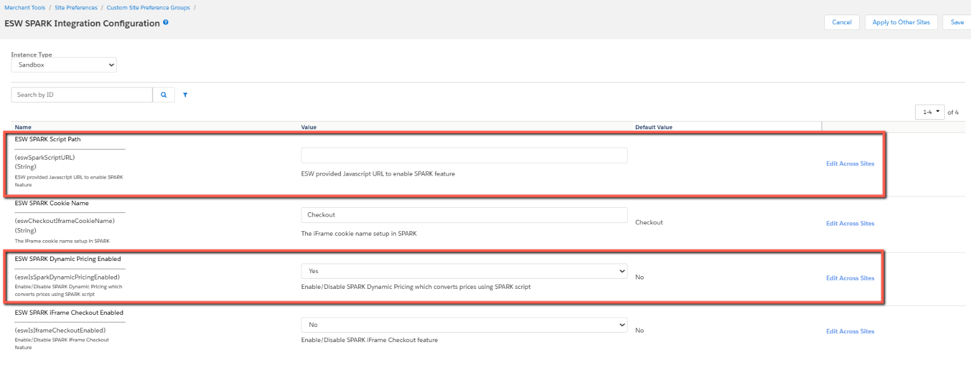
Retailer display configurations
If you decide to use the ESW LTI Country Selector, it will be automatically generated by the Spark script. In this case, you’ll need to update a few settings in SFCC Business Manager by going to:
Merchant Tools > Site Preferences > Custom Site Preference Groups > ESW Retailer Display Configuration
Update the following configurations accordingly:
- ESW Enable Landing Page – set to No
- ESW Enable Country Selector on Landing Page – set to No
- ESW Enable Currency Selector on Landing Page – set to No
- ESW Enable Language Selector on Landing Page – set to No
- ESW Enable Bar on Header Page – set to Yes if the country selector should appear in the header, No otherwise
- ESW Enable Bar on Footer Page – set to Yes if the country selector should appear in the footer, No otherwise
Configure custom objects:
Spark pricing conversion is designed to work only with dynamic pricing countries. Therefore, it’s important to ensure that the LTI-enabled countries in ESP are also configured as non-fixed price countries in SFCC. If these settings are not aligned, shoppers may not be redirected to checkout properly, and product prices may not display correctly on the storefront.
To configure dynamic price model country, please follow below steps:
- Goto: Merchant Tools > Custom Objects > Manage Custom Objects
- Set “ESW_COUNTIRES” custom objects from the drop down
- Search the country which needs to set a dynamic pricing model for example IE
- Select the country 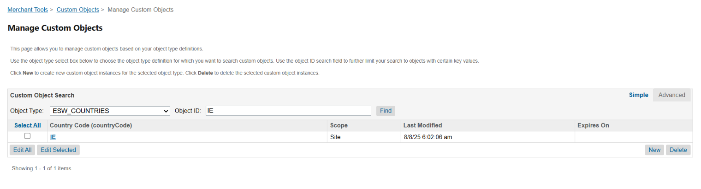
- Make sure to
  - Uncheck “Is Fixed Price Model:”
  - Check “Is ESW Supported Country:”
- The country configuration is shown in the screenshot below.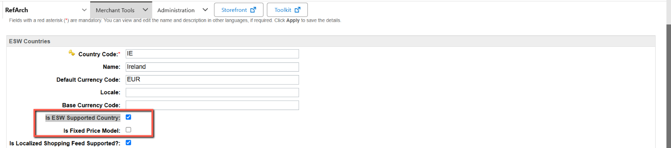
Upload and compile cartridges:
- To use spark with SFRA the cartridge path should be: int_eshopworld_spark:int_eshopworld_sfra:int_eshopworld_core
- To compile assets for spark run following commend in link_eshopworld folder:
  - npm run compile:js:spark && npm run compile:scss:spark

Code Customization
The ESW SFCC cartridge includes a helper function that allows you to add specific classes to storefront elements. These classes are only added when the related feature is enabled, ensuring they don’t appear in the HTML DOM unnecessarily.
The pricing integration table detail is below:
Name | Purpose
cart-price | Shows the unit price of each product.
cart-item | Represents a single line item container in the cart.
cartItem-quantity | Displays the quantity of a specific item in the cart.
cartItem-subtotal | Shows the total price of an item (unit price × quantity).
cart-subtotal | Displays the subtotal of all items before discounts or fees.
cart-total | Shows the final total of the cart, including all charges and discounts.
page-price | Used for general prices on any page (not included in calculations). Ideal for promotion callouts or static content.
discount-item | Represents any discount amount applied on the cart page — included in total calculations.
minicart-subtotal | Displays the subtotal in the mini cart view.
minicart-item | Shows the unit price of a product within the mini cart.
minicart-price | Used for pricing within mini cart line items (e.g., .esw-cart-line-item-unit-price).
minicartItem-quantity | Displays the quantity of each product in the mini cart.
minicartItem-subtotal | Shows the subtotal for items in the mini cart.
singleItem-discount | Displays the discount applied to an individual line item.
surcharge-item | Represents any extra charges such as shipping, tax, or handling fees.
The cartridge automatically handles quantity and discount updates on the standard SFRA storefront. The retailer simply needs to add the appropriate classes based on the HTML structure recommended by the Spark script.
Calling helper function to add class in the DOM:
To integrate spark pricing you need to call the helper function in the relevant ISML as follows:
- Include eswHelper in the ISML:
- <isset name="eswHelper" value="${require('*/cartridge/scripts/helper/eswHelper').getEswHelper()}" scope="page" />
- Use the helper function “eswHelper.applySparkClassToDom(‘html-class’)” in your ISML file to generate the required class, as shown in the example below.
- <span class="any-class ${eswHelper.applySparkClassToDom('esw-general-price')}">${price.decimalPrice}</span>

Example Screenshots – Adding class to elements in SFRA
The table below shows the default pricing integration configuration, including the classes used in the ESW cartridge.
You can use these classes as a recommended reference when setting up your own storefront implementation.
Disclaimer: These classes can be customized based on the retailer’s specific code implementation. The ESW integration team can assist retailers in adding new or updating existing classes on the ESW tenant side.
Name | Value (CSS Selector)
cart-price | .esw-cart-line-item-unit-price
cart-item | .esw-cart-item
cartItem-quantity | .esw-cart-quantity
cartItem-subtotal | .esw-cart-line-item-total-price
cart-subtotal | .esw-cart-subtotal
cart-total | .esw-cart-total
page-price | .esw-general-price, .esw-price
discount-item | .esw-discount
minicart-subtotal | .esw-minicart-subtotal
minicart-item | .esw-minicart-item
minicart-price | .esw-cart-line-item-unit-price
minicartItem-quantity | .esw-cart-quantity
minicartItem-subtotal | .esw-cart-line-item-total-price
singleItem-discount | .esw-general-price
surcharge-item | .esw-cart-surcharge
The following screenshots illustrate how Spark is implemented in the default SFRA storefront, helping developers understand its integration more clearly.

PLP/Product Card
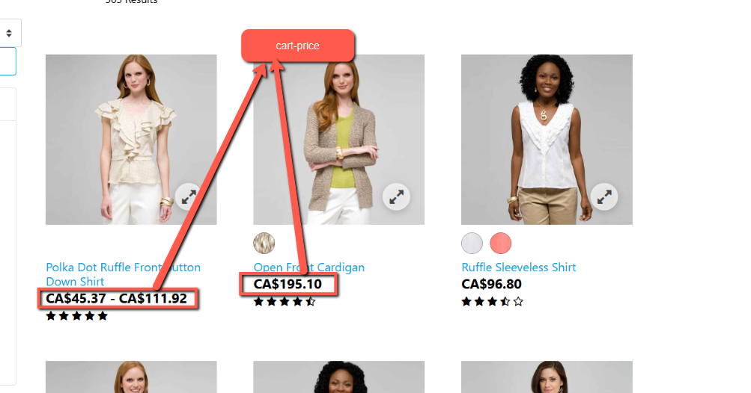
PDP
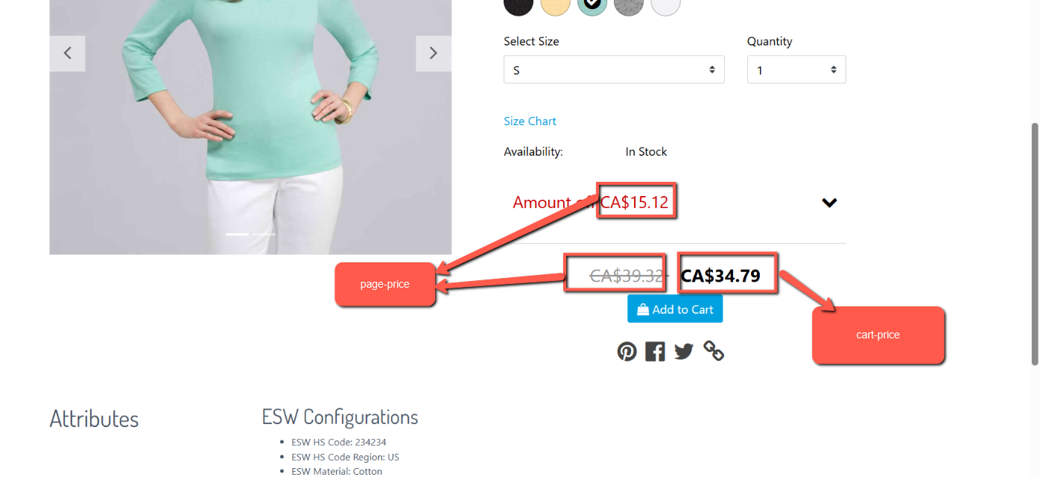
Cart page Product line item 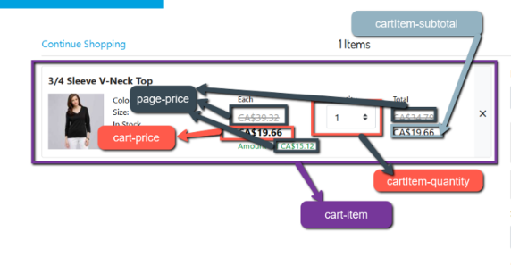
Cart page totals
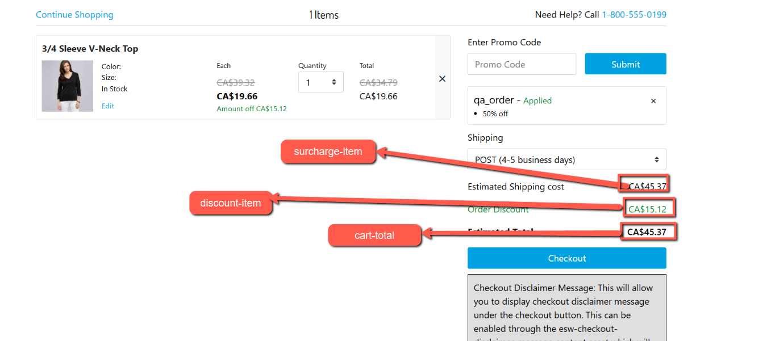

Mini Cart
